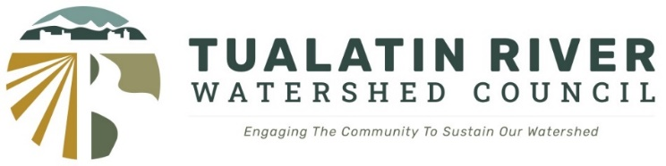

Draft Agenda

November 6, 2024
7:00 – 8:30 pm

- Meeting Called to Order – Rahim Harji
- Introductions
- Introduction of New CWS representative – Lisa Huntington
- Review and Approval of Agenda – Rahim Harji
- Special Watershed Focus – Confluence of West Fork Dairy and Cedar Canyon Creek (City of Banks)
  - PRESENTATION: Killin Wetlands Nature Park – Management overview, habitats and hydrology

Jeff Merrill is a Senior Natural Resource Scientist for Metro’s Parks and Nature Department. He acts as one of nine Natural Resource Scientists supporting the restoration and stewardship of Metro's portfolio of over 18,000 acres of parks and natural areas through restoration project planning and implementation, site stewardship, and collaboration with regional partners. He holds a Bachelor’s degree in Natural Resource Management from Oregon State University and has worked for Metro Parks and Nature from 2009 to 2019 and again from 2022 to present.

  - PRESENTATION: The Dairy Creek Mitigation Bank – Jonas Moiel
Jonas Moiel is a Senior Scientist with 20 years of natural resource consulting experience. Mr. Moiel specializes in environmental mitigation, restoration ecology, and natural resource management. He has managed numerous environmental projects including wetland delineations, wetland mitigation banks, federal and state permitting, rare plant surveys, vegetation monitoring, water quality studies, ground water and soils studies, geographic information systems (GIS), fisheries surveys, and biological assessments. His strongest area of expertise is native plant ecology and restoration. Oregon.

- Public Comment
- Approval of June 2024 Minutes – Mark Fitzsimons
- Approval of October 2024 Minutes – Mark Fitzsimons
- Adjourn

